NAAN MUDHALVAN SALESFORCE REPORT

COLLEGE : **SCAD COLLEGE OF ENGINEERING AND TECHNOLOGY**

BATCH – 17

|  |  |  |
| --- | --- | --- |
| **NAME** | **NM ID** | **REG NO** |
| **MALKKAMALI T B** | **43F94DDC618BE6A90354ABBB552A0D5B** | **952820114329** |
| **PACKEER MYDEEN A** | **EB5079845373C0A95E04F7EE14174A9A** | **952820114344** |
| **SYED ANWAR S** | **75AA491371336EC88324AE1AB7027FFD** | **952820114359** |
| **MIYAKHAN K** | **308FB68C695FC6B85904617648ABCA0E** | **952820114331** |

**Step 1: Create a Salesforce Account**

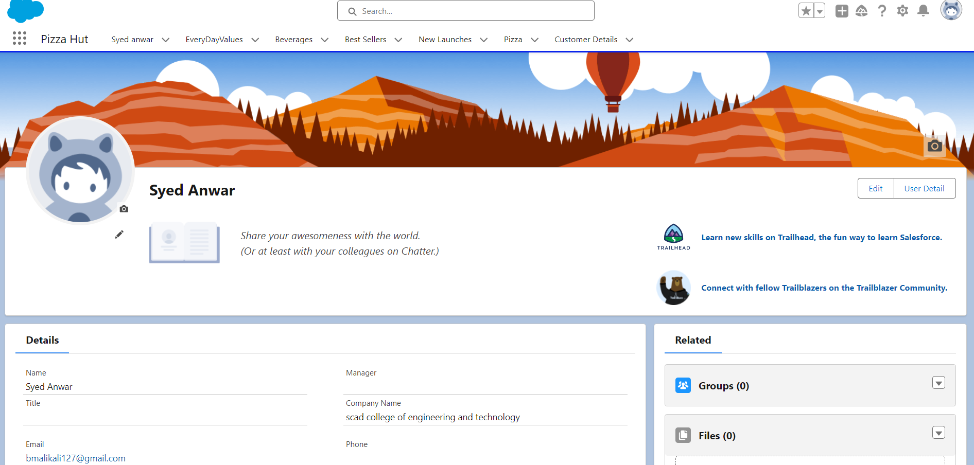

**Step 2 : Create the Objects( Customer Detail,Everyday Value,BestSeller,NewLaunches,pizzaTypes,Beverages,ModeOfPaymentt)**

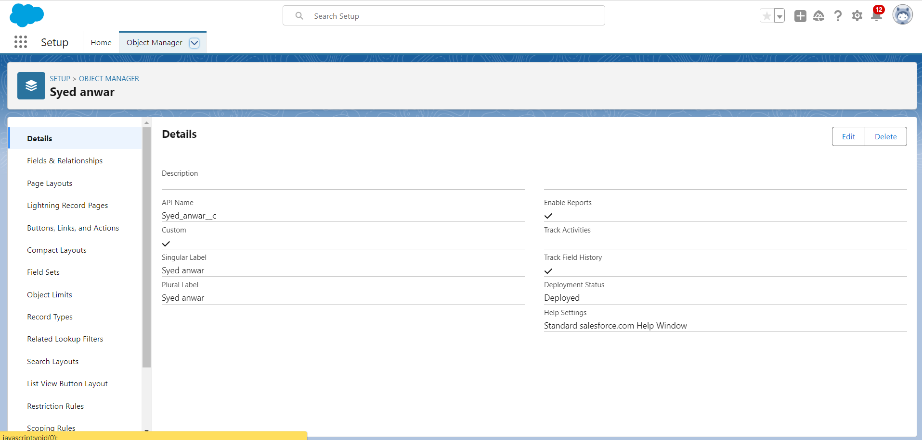

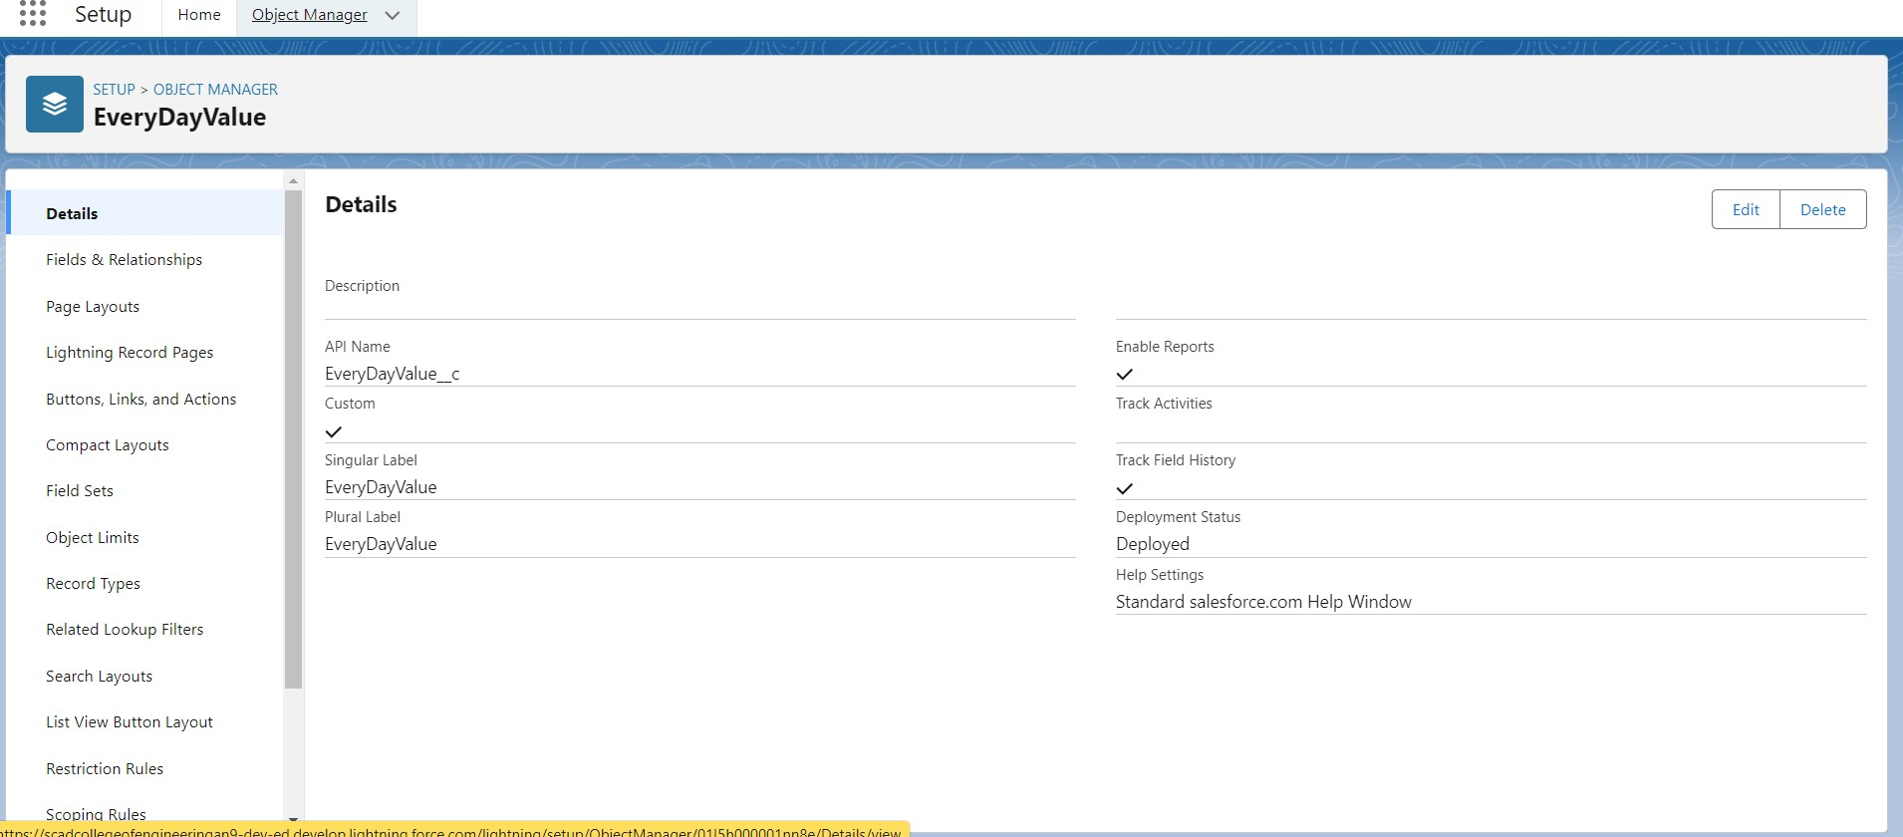

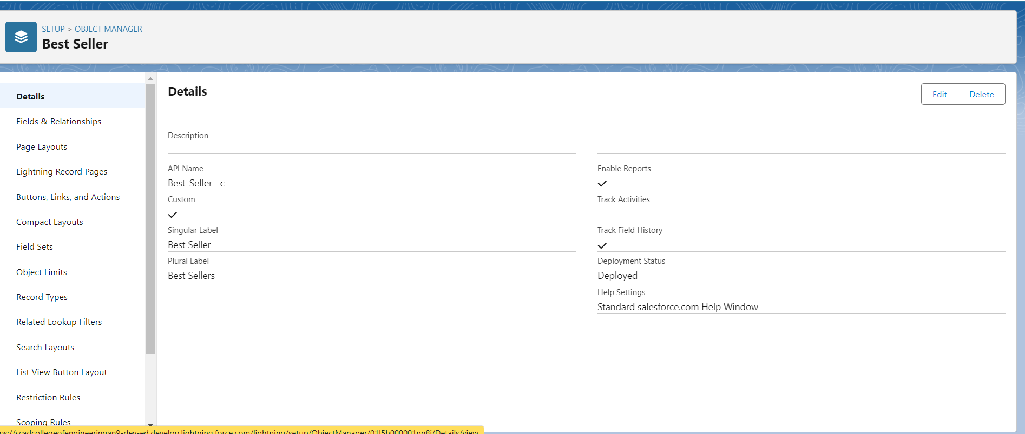

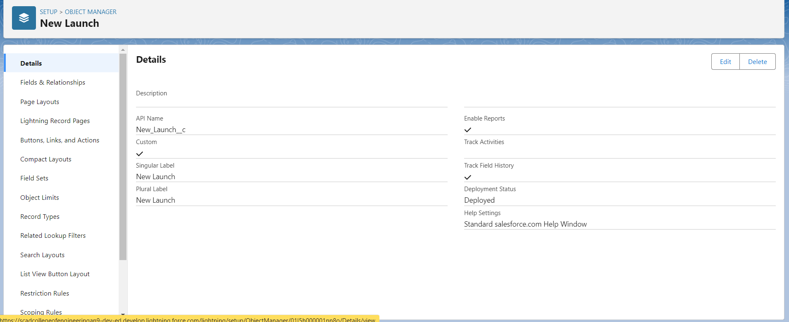

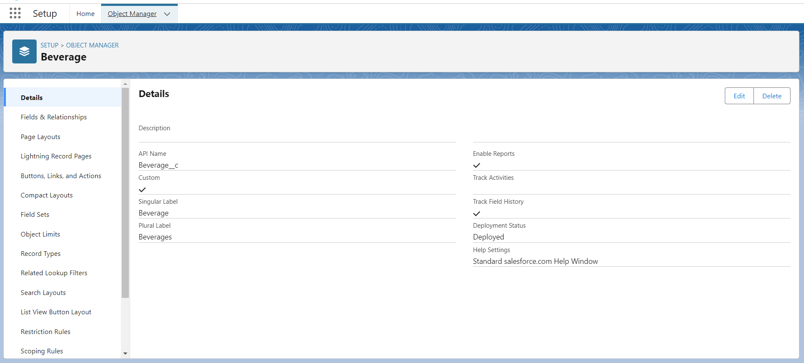

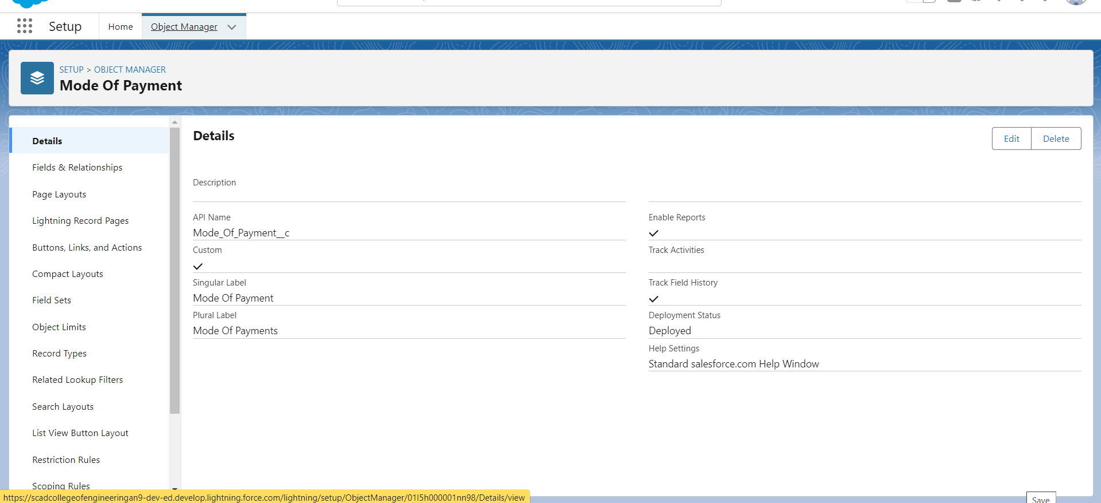

**Step 3 : Create Fields&Relationship Objects(Customer Detail,Everyday Value,BestSeller,NewLaunches,pizzaTypes,Beverages,ModeOfPayment)**

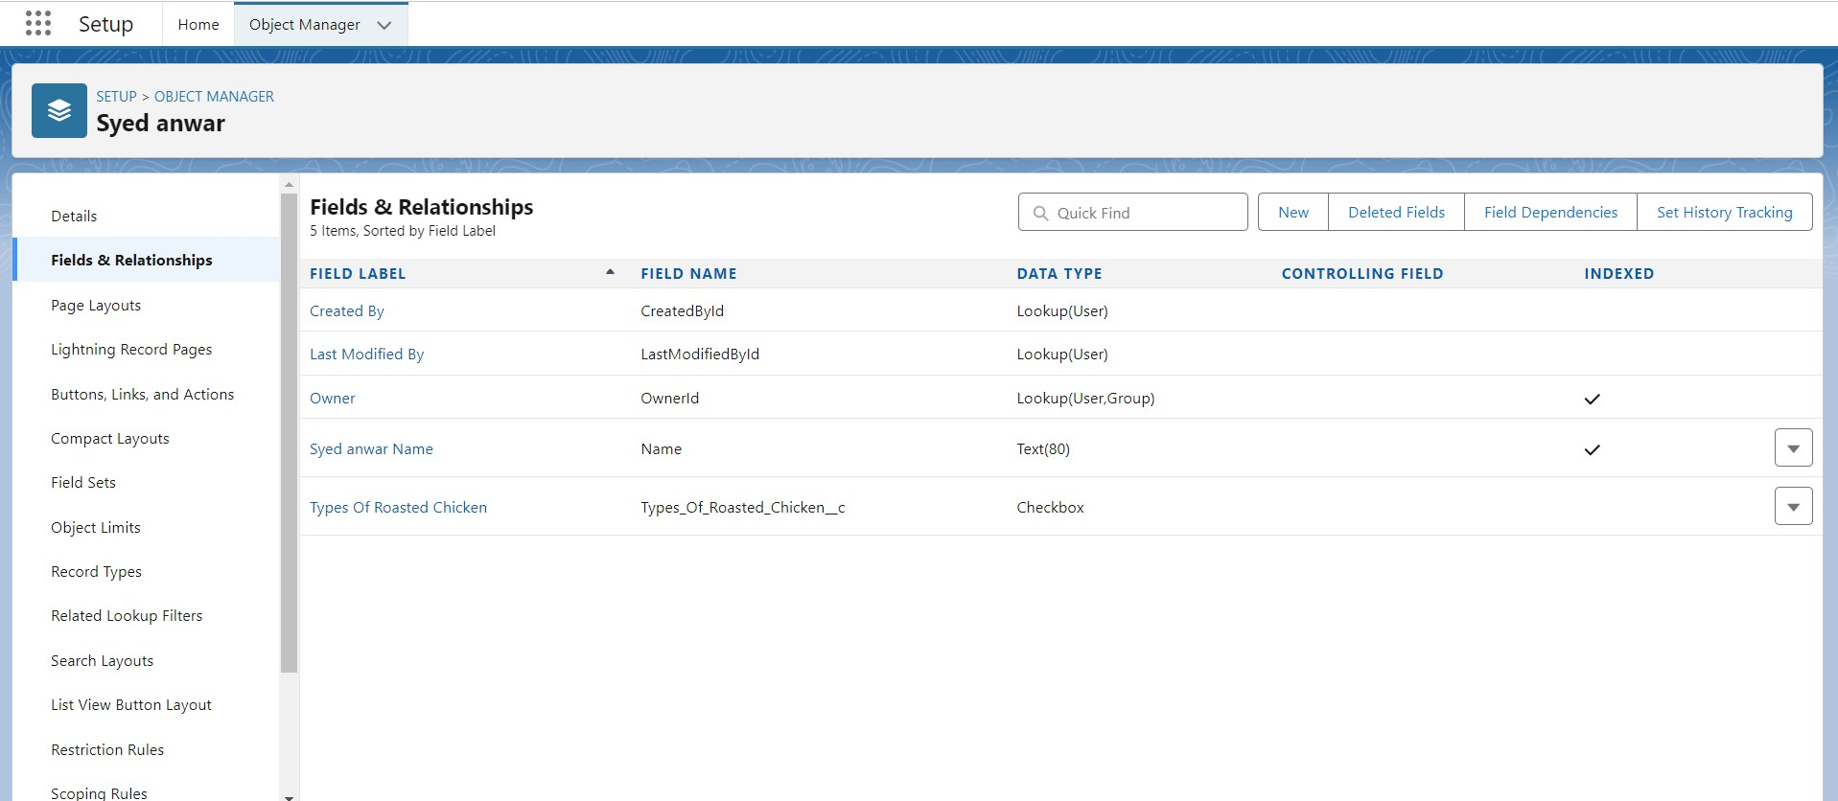

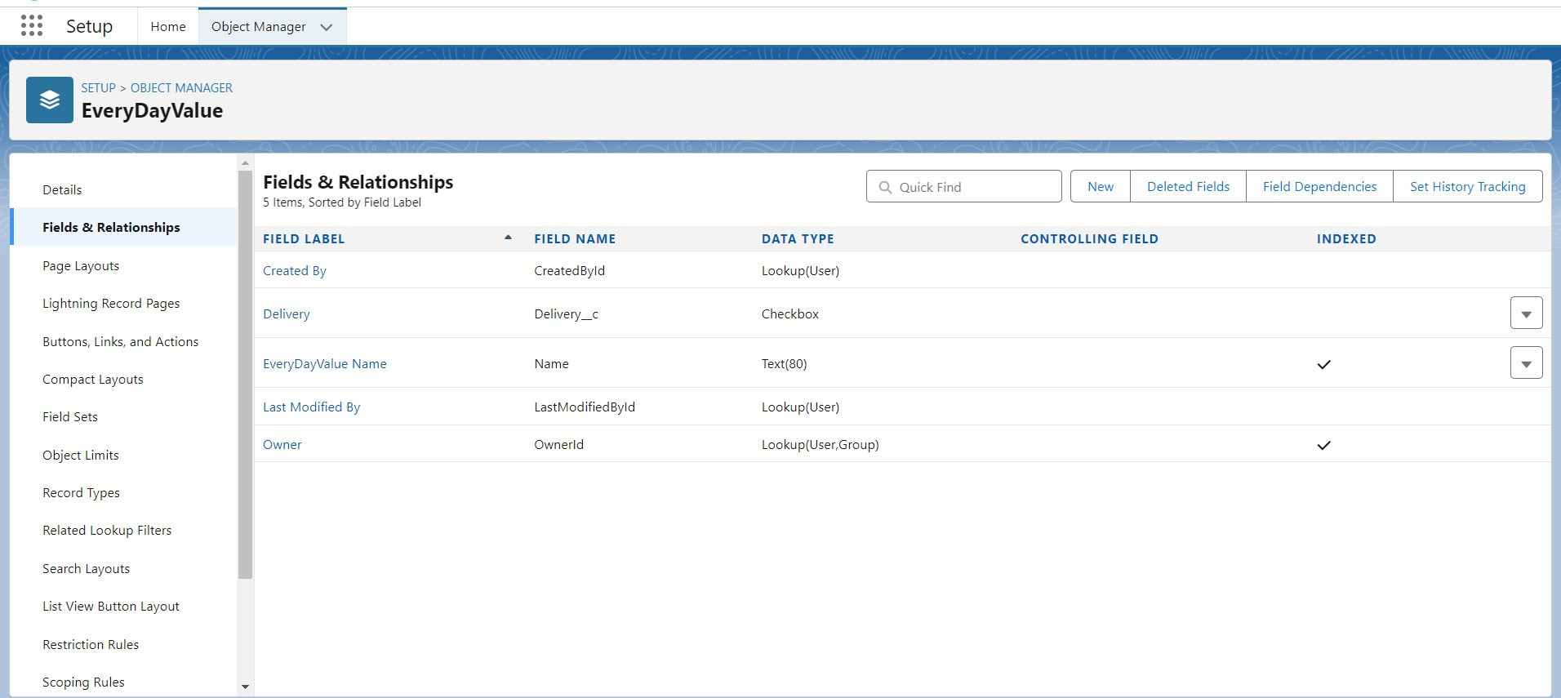

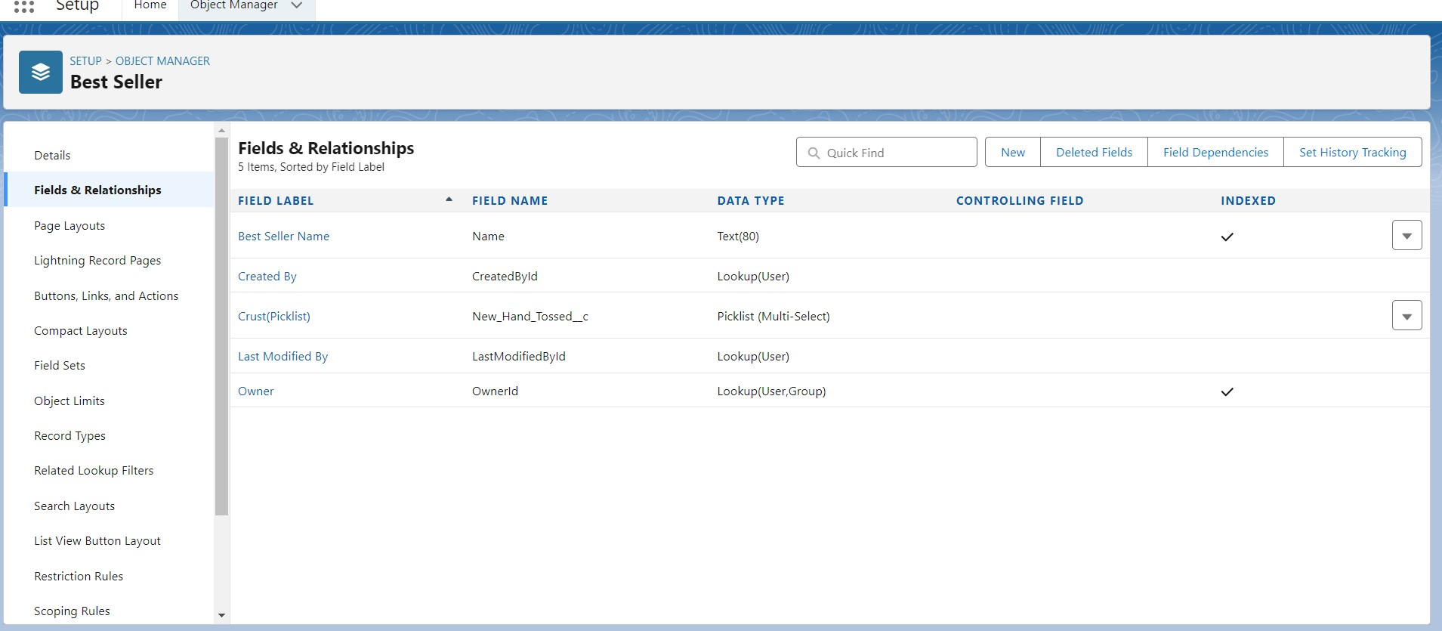

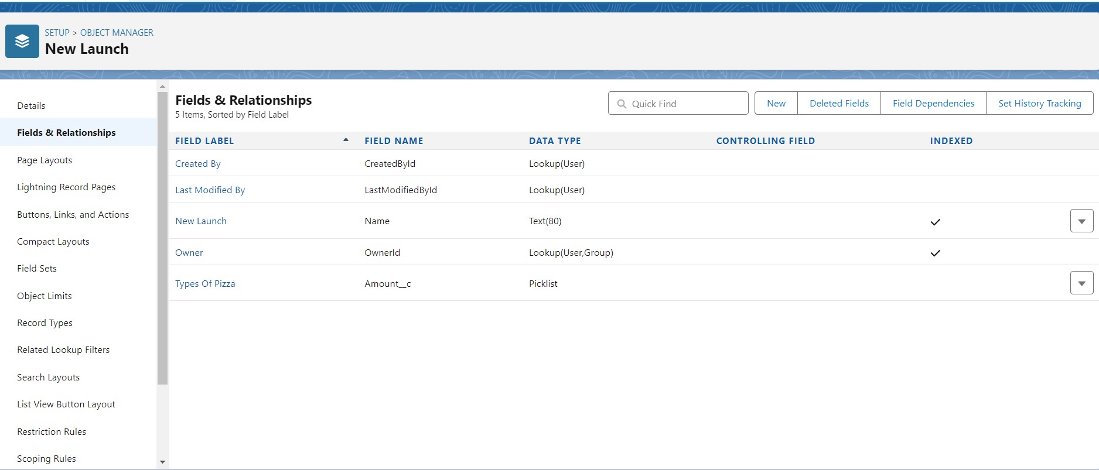

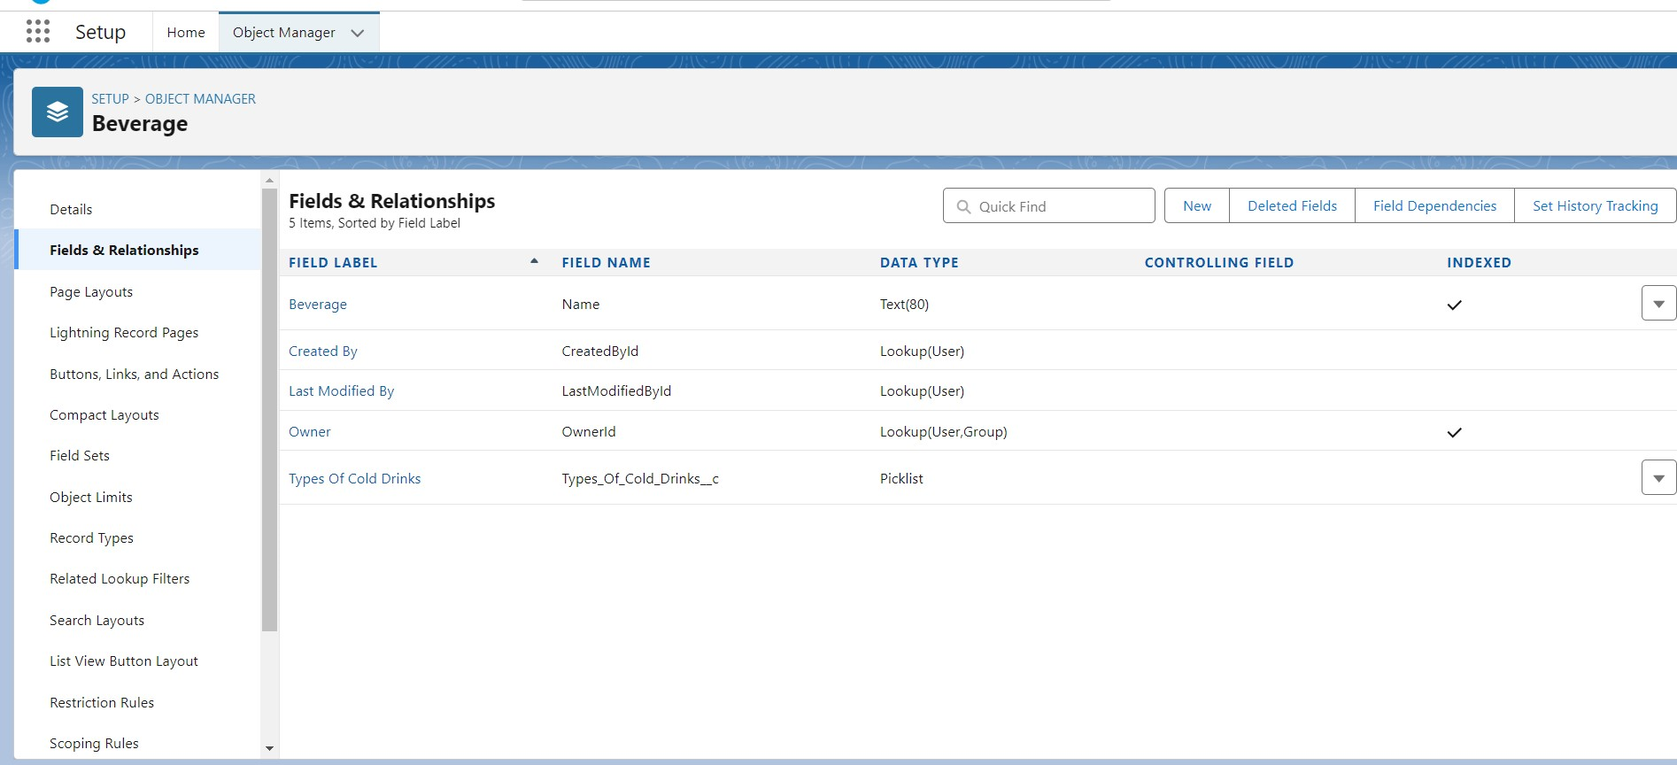

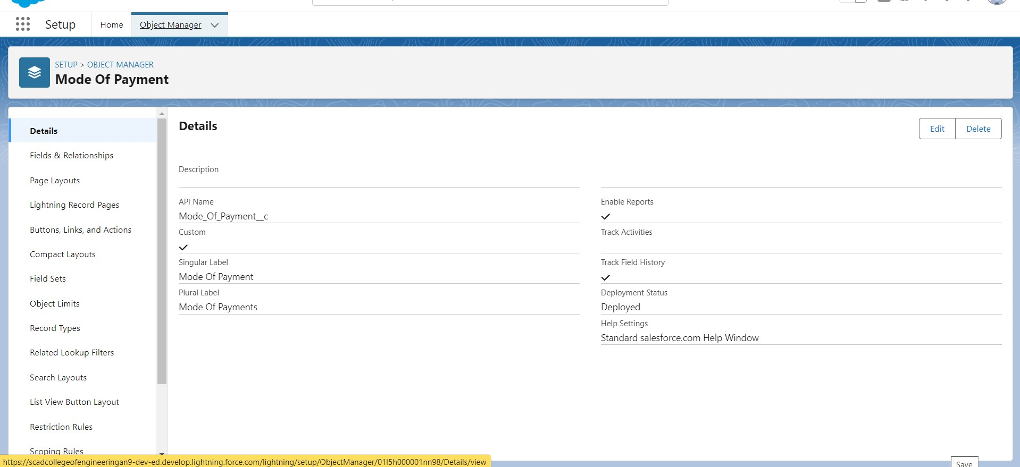

**Step 4 : Create the Tabs for each object(Customer Detail,Everyday Value,BestSeller,NewLaunches,pizzaTypes,Beverages,ModeOfPayment)**

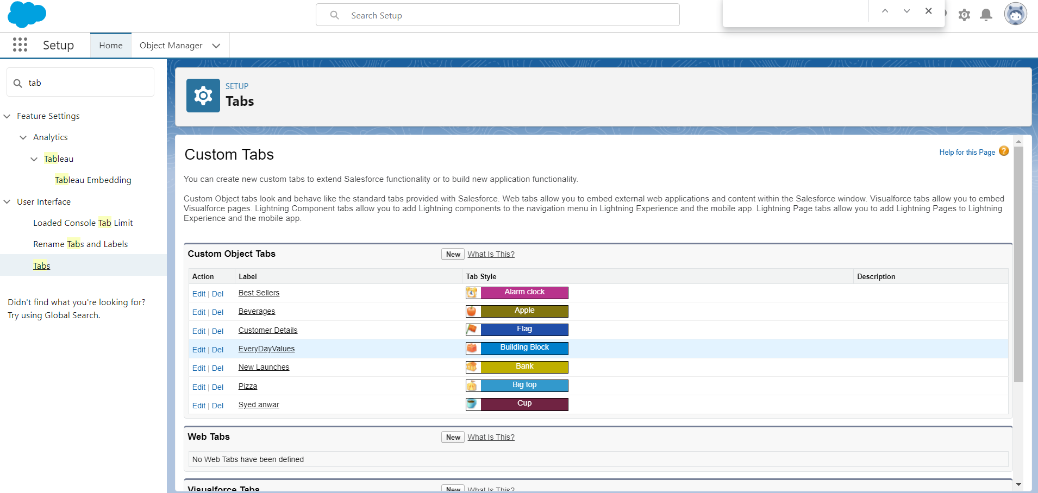

**Step 5 : Create a Lightning App**

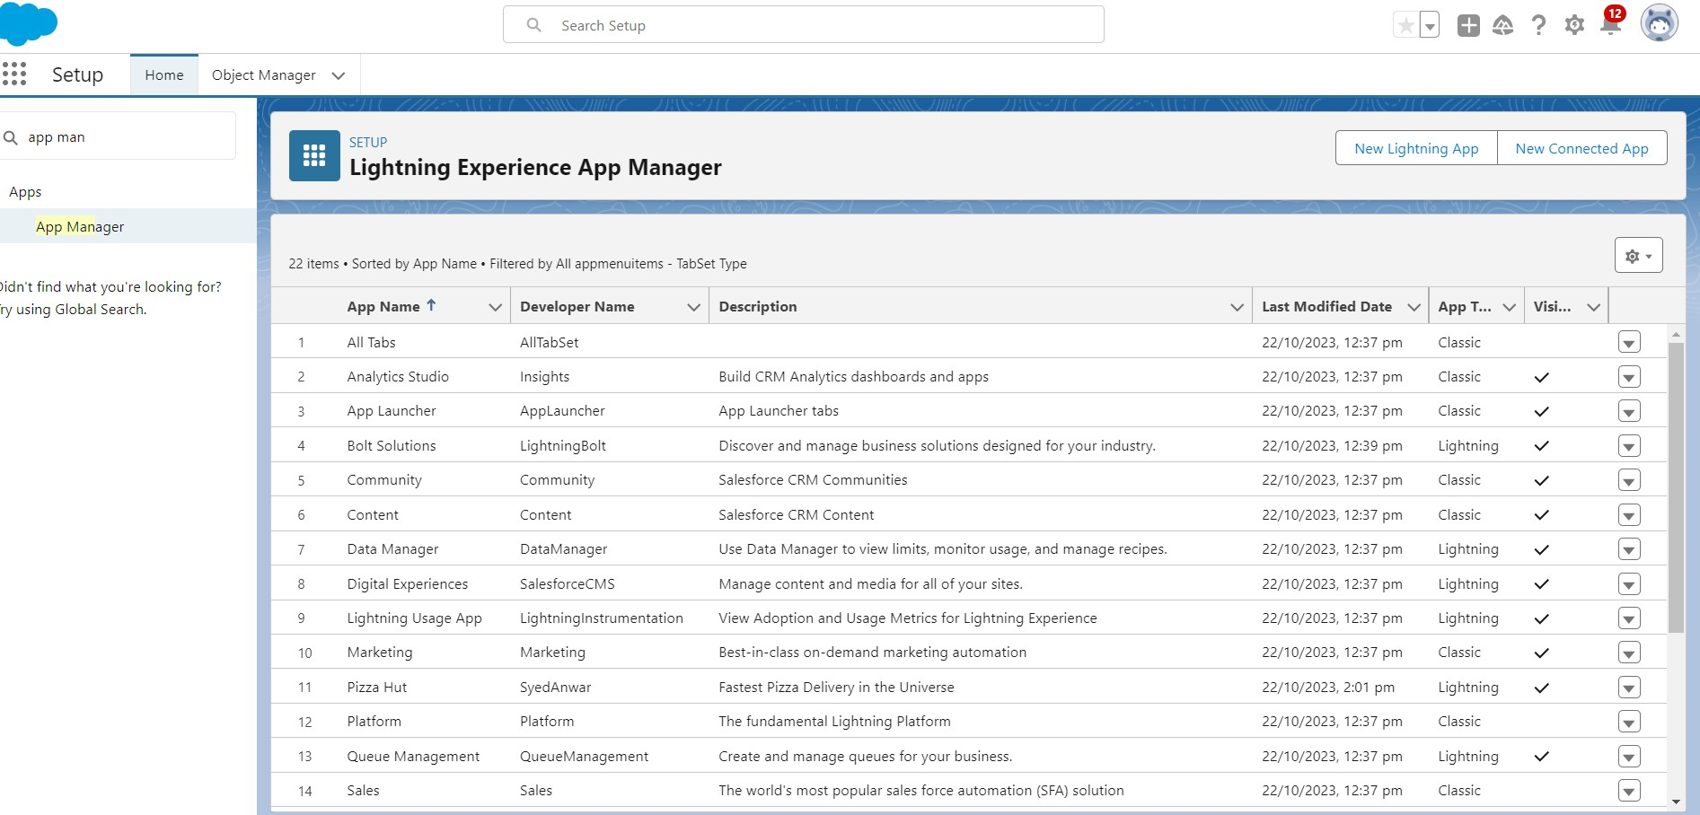

**Step 6 : Create the pizza app profile**

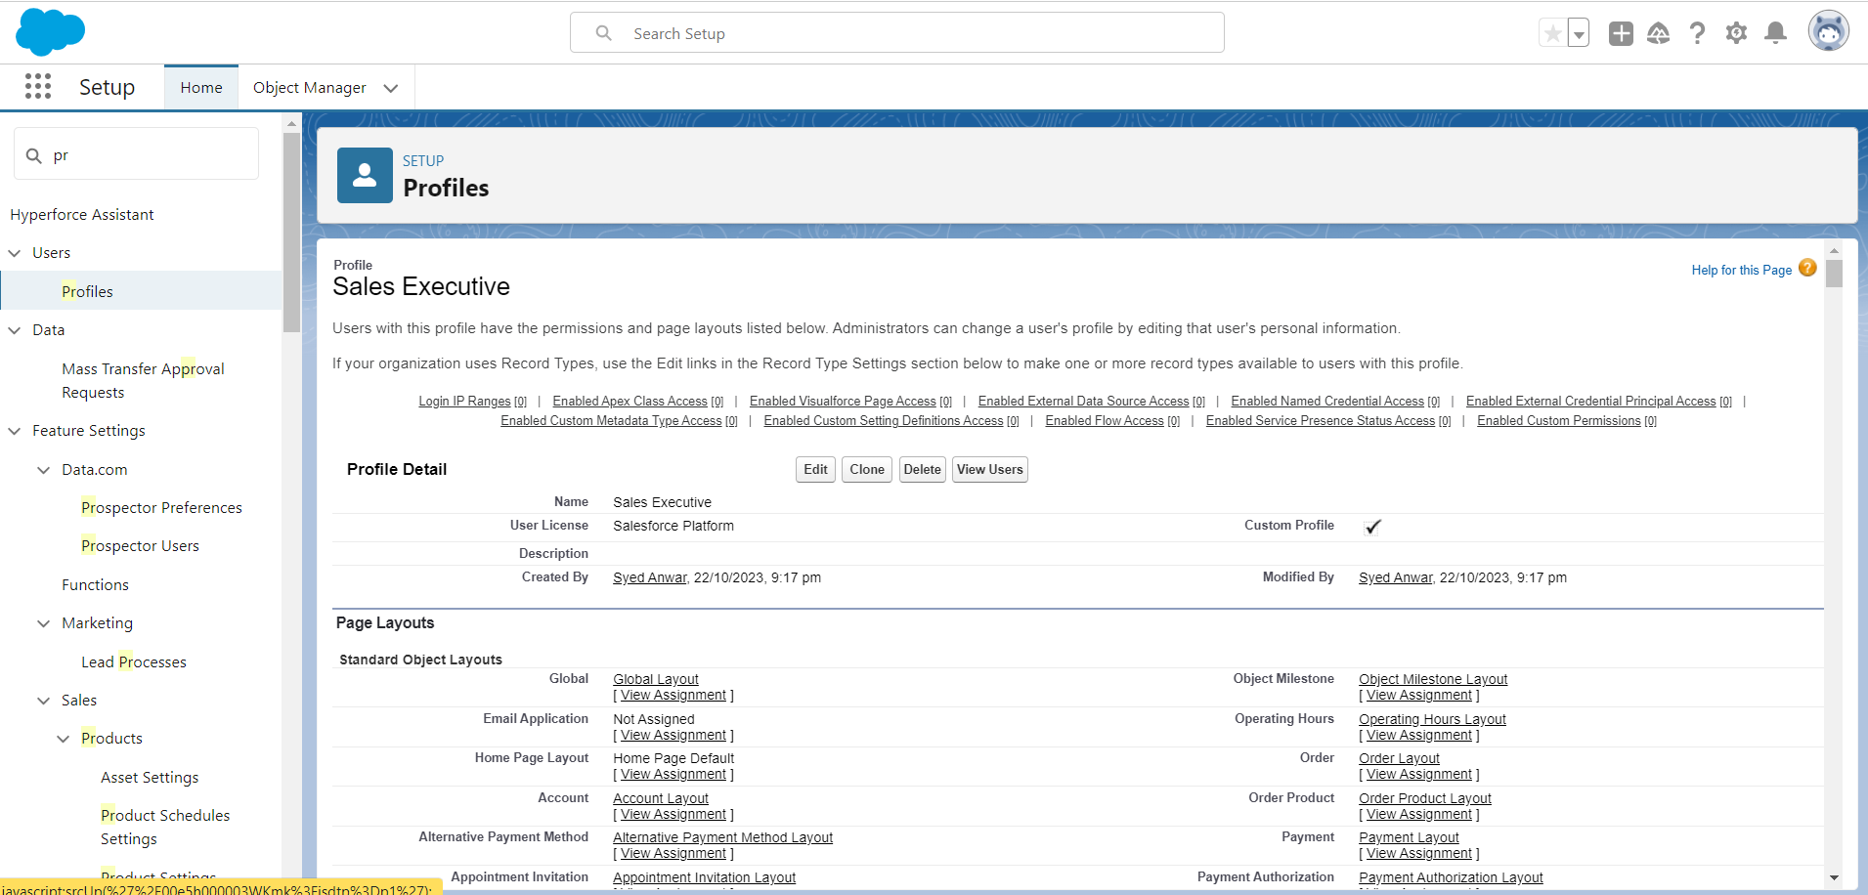

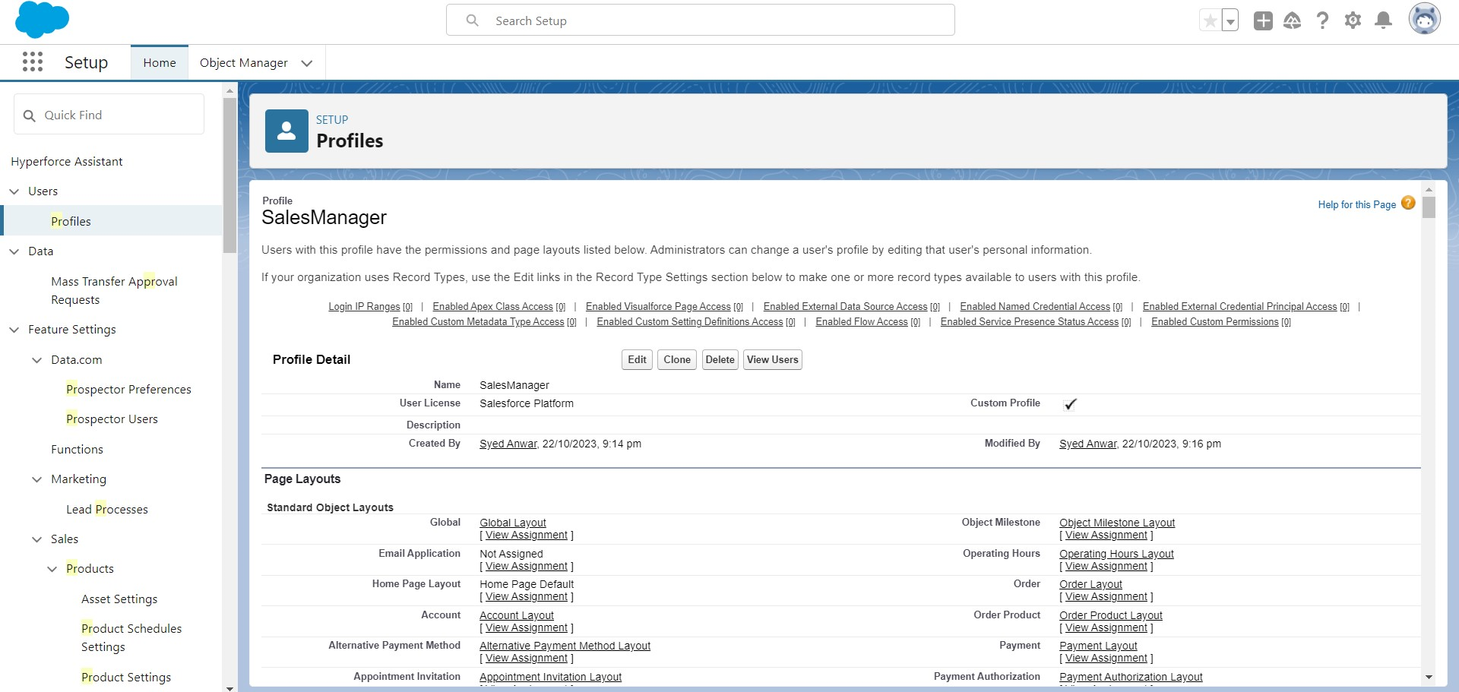

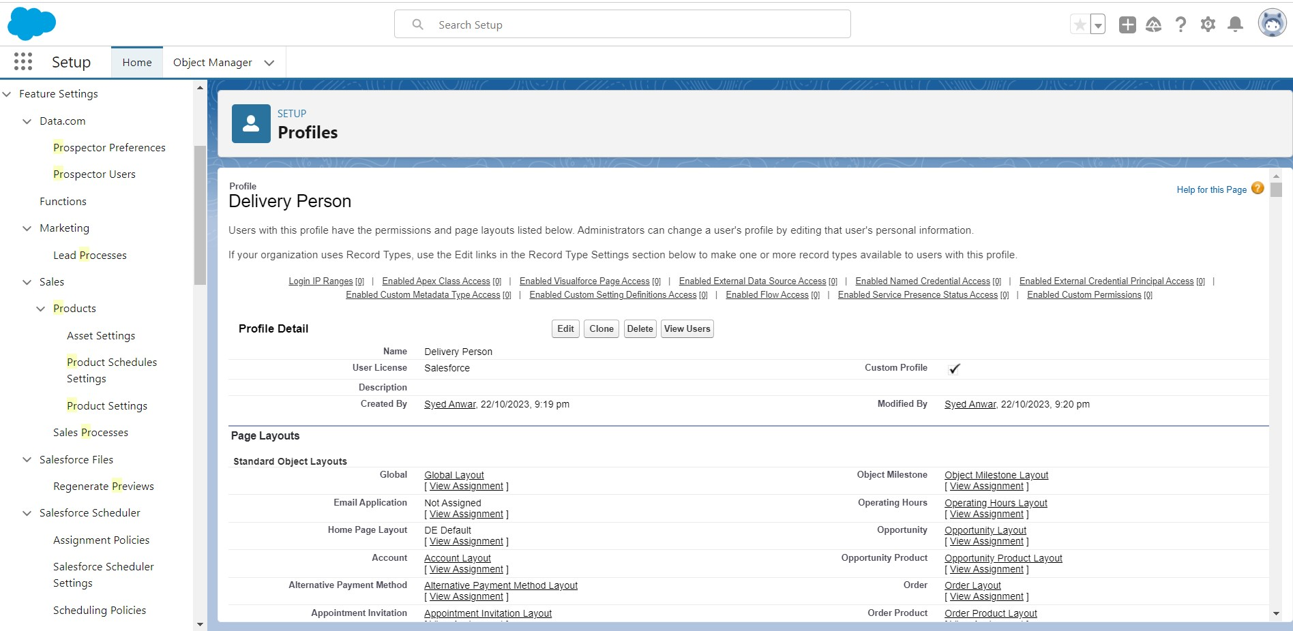

**Step 7 : Create the users(Teacher , Parent , Principal)**

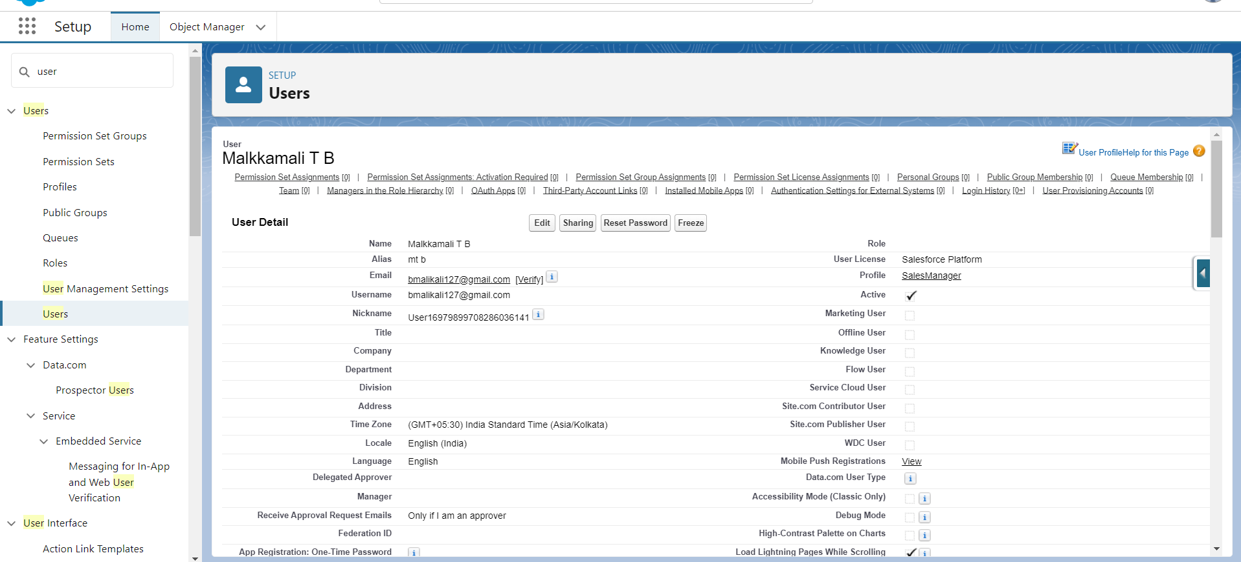

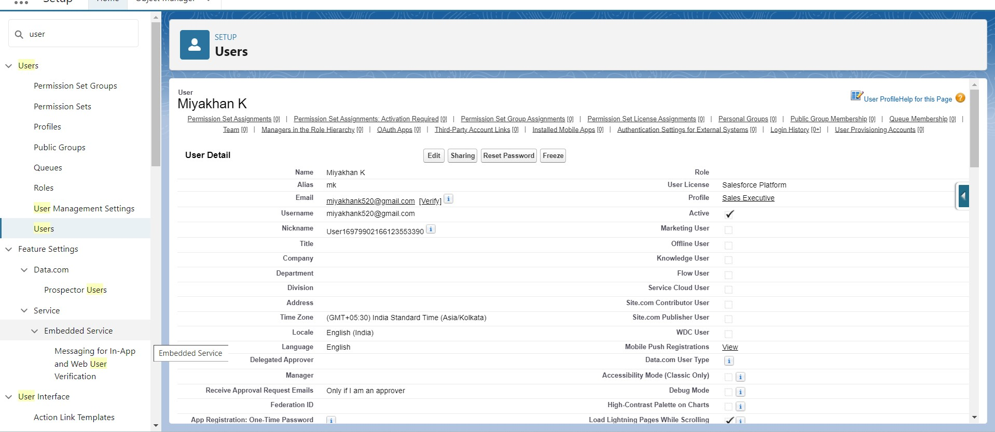

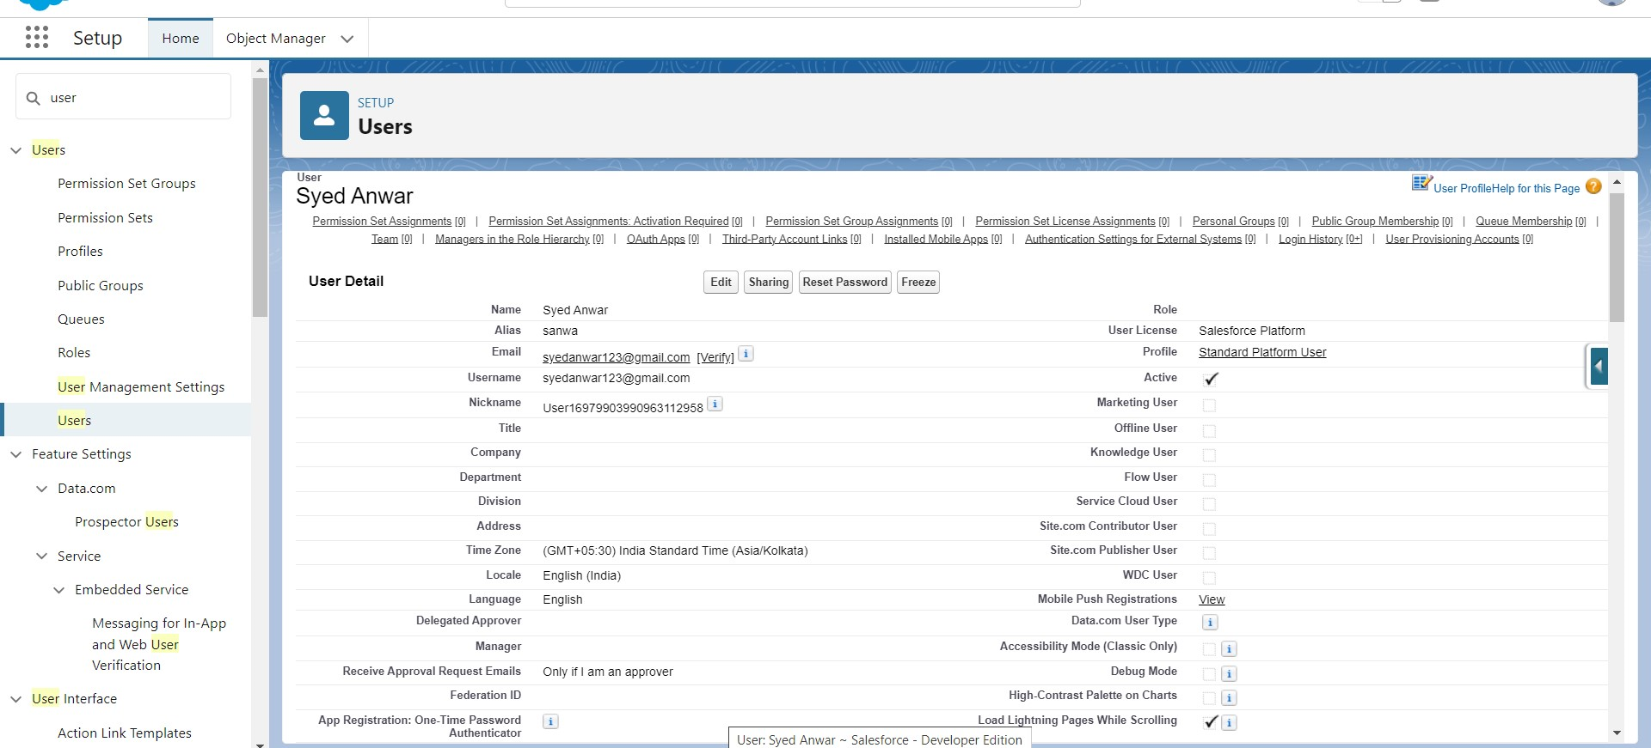

**Step 8 : Create the Organization-wide defaults area**

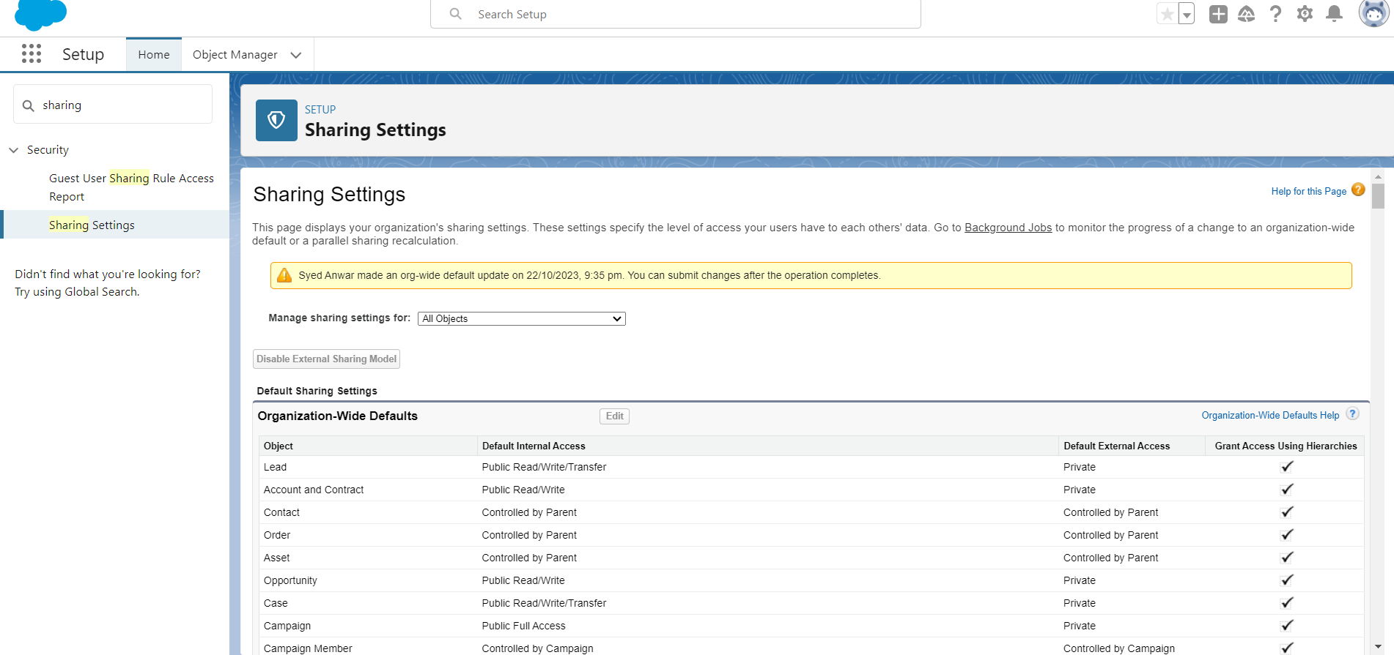

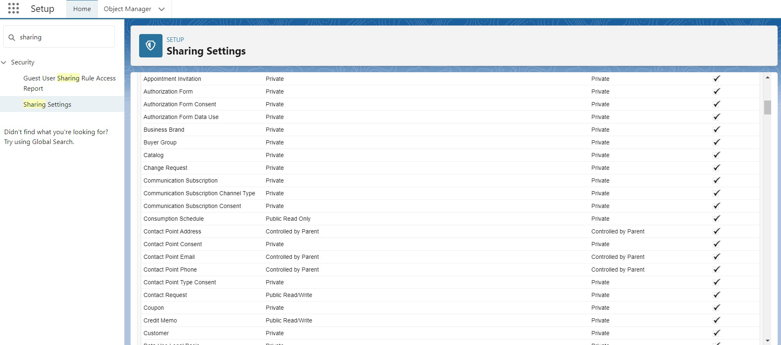

**Step 9 : Create Report**

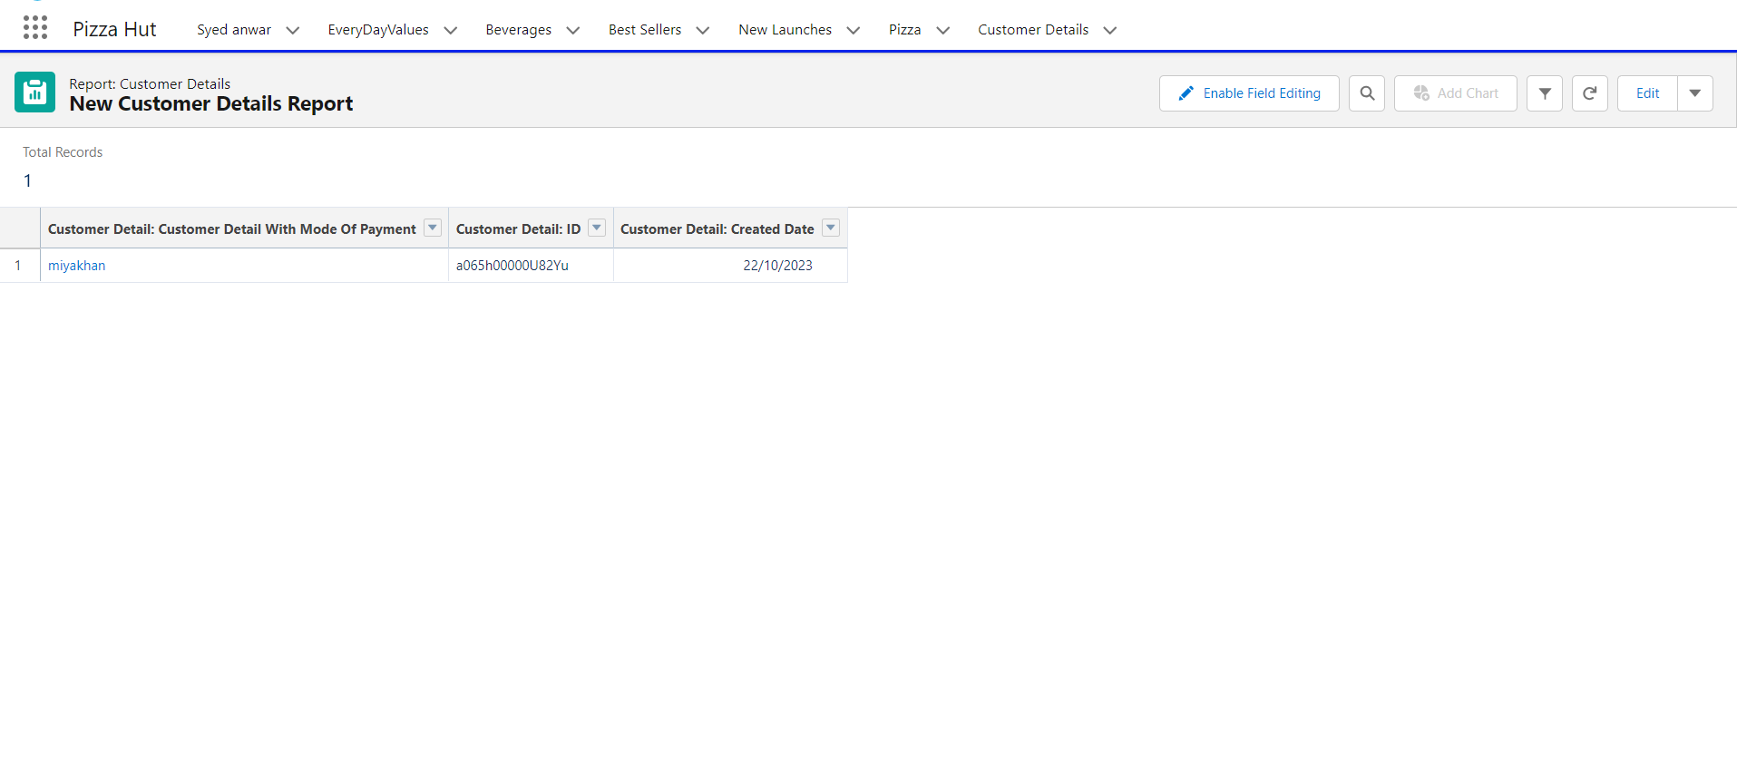

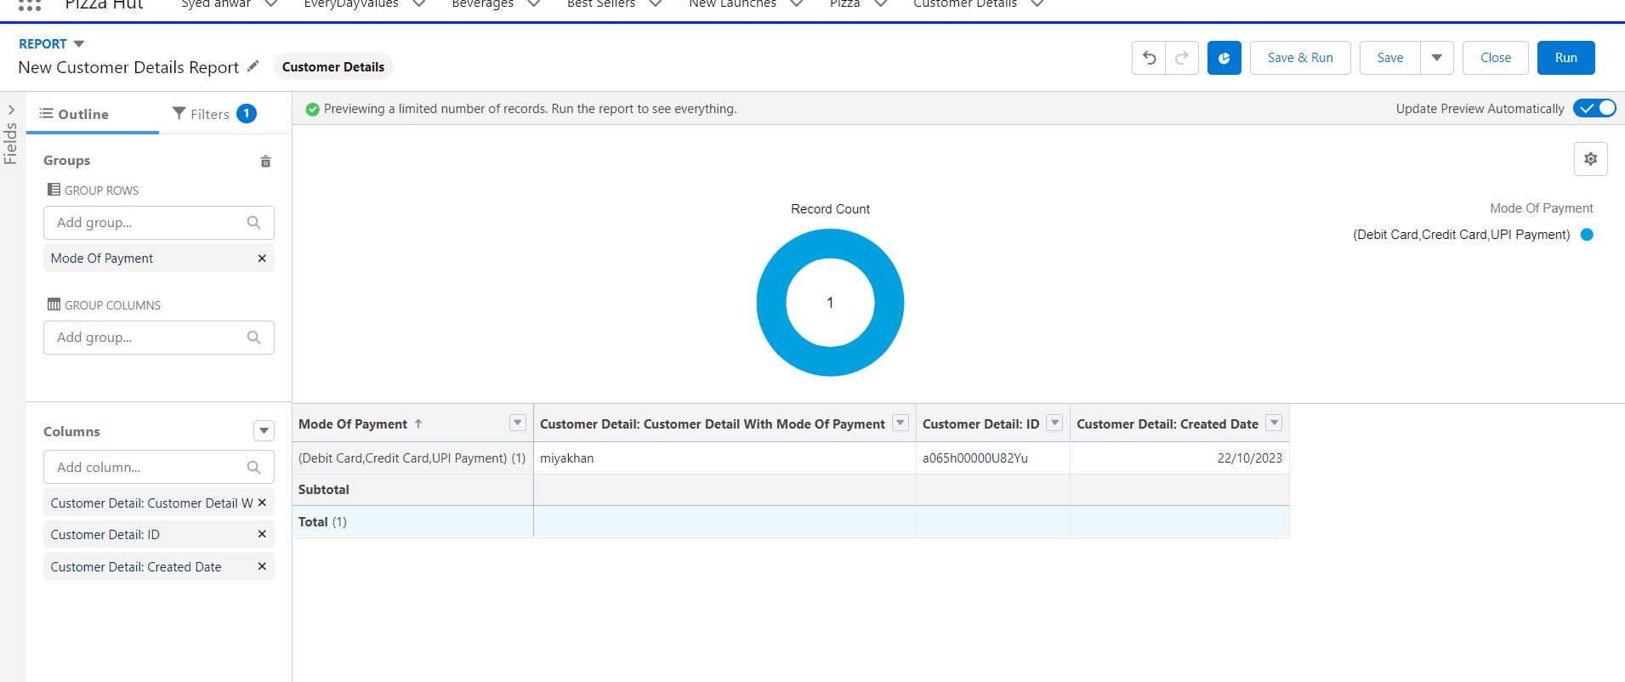

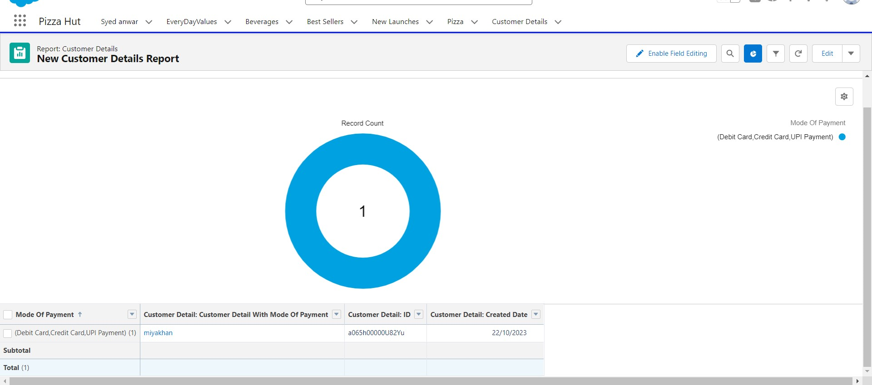

**Step 10 : Create the Apex Trigger**

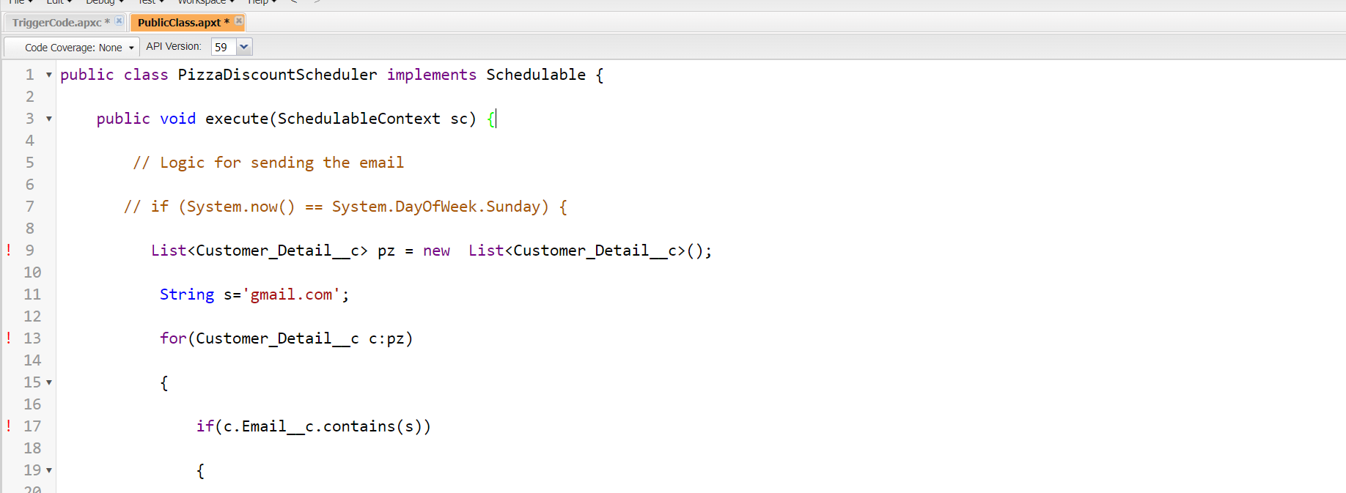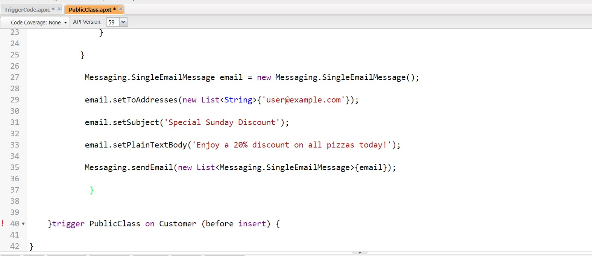

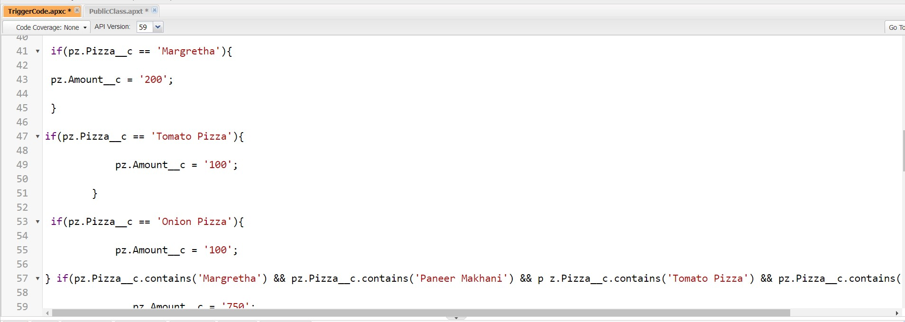

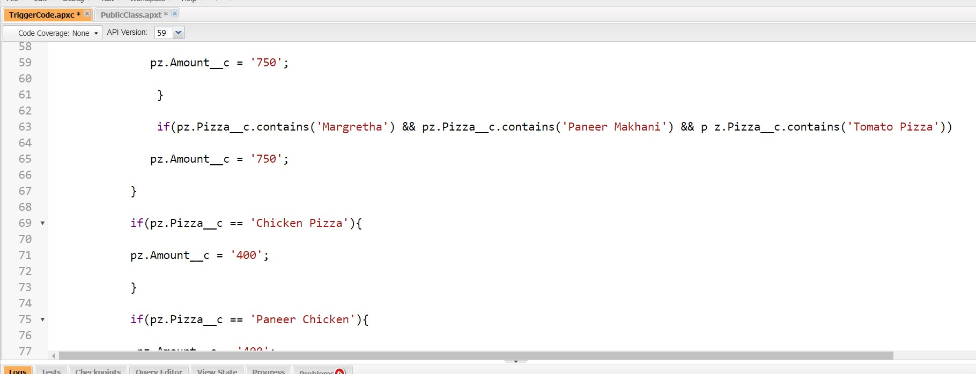

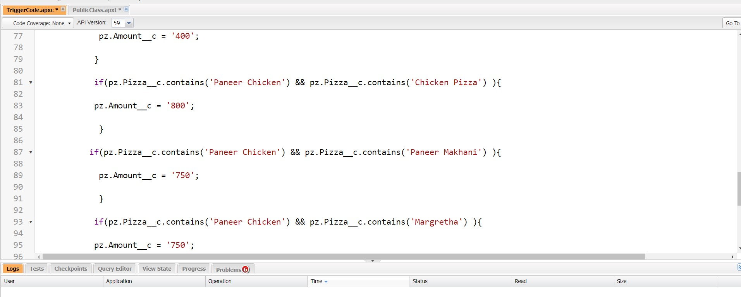

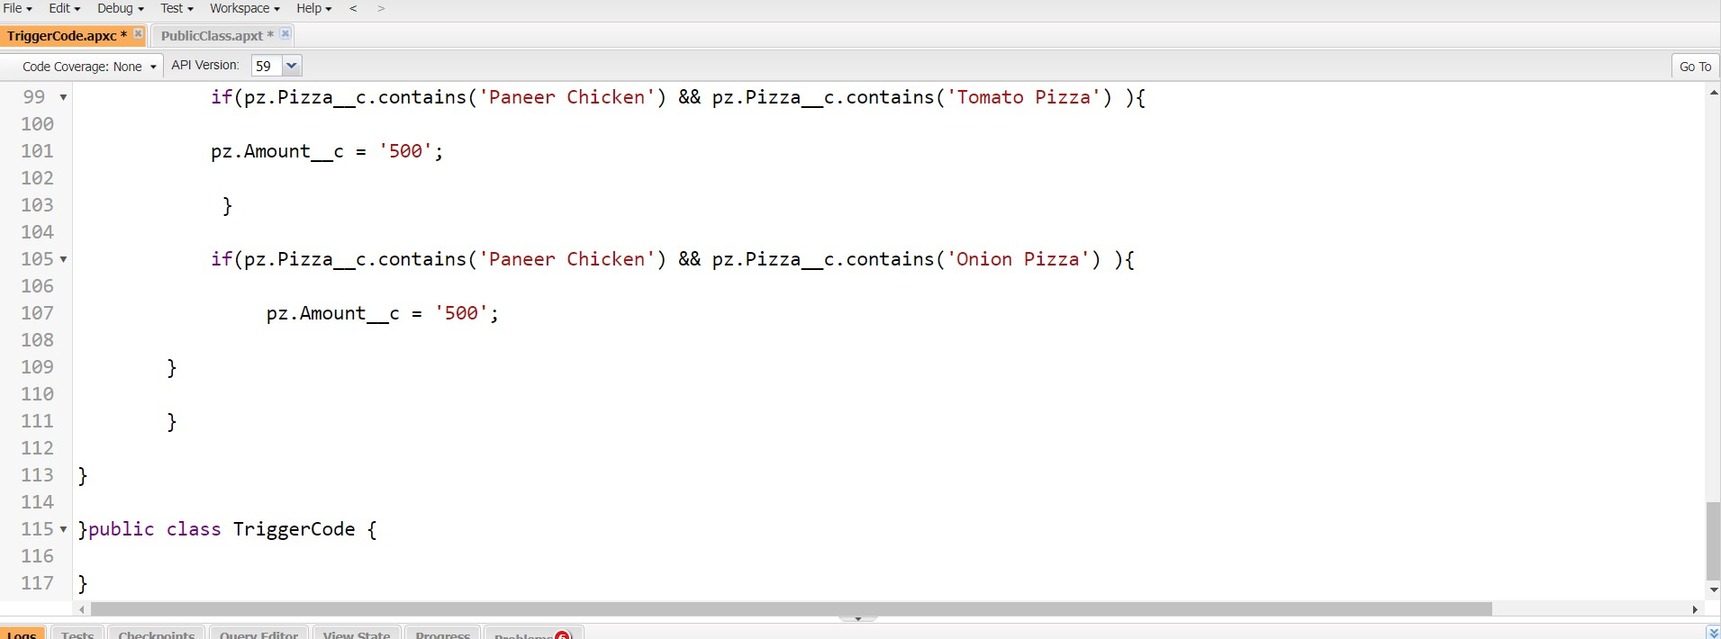

**Step 11 : Create the Schedule Apex**

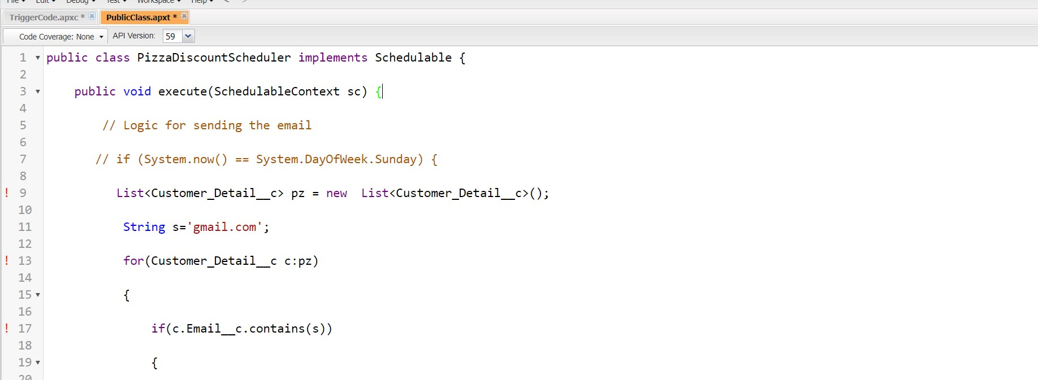



**Thank You**